Antonella House’s Rules

Our house is your house, so please treat it with respect as if it were your own.
We do not allow smoking in the house, you can go outside, but remember to bring the ashtray!
Thank you for not flushing anything down the toilets but the toilet paper we provide.
Any spills or damage shall be reported immediately; we understand breakage happens and we would like to assist you with clean up if necessary.
Additional guests are not allowed.
Don’t park your car in via Cavour and viale Elvezia on Sunday and Wednesday night because there will be an open air street market the day after. The car will be towed away and fined by the police!
Close any windows and turn off the lights when you are not in.
Before leaving, have a look in all the wardrobe, drawers and rooms not to leave any personal belongings, battery chargers, sunglasses.
Always lock the main door, and check the gate downstairs is properly closed.
Thank you, have a pleasant stay

Antonella’s mobile +39 335 7812002

Wi-Fi connection: ID FastwebABC
PASSWORD Milano1999

Code for the key box: 8789

What you can find in the house:
- Iron and table for ironing in the wardrobe in the left bedroom
- Sewing kit in the bathroom cabinet
- Tourist guides and leaflets in the left bedroom
- Toys for kids in the drawers in the left bedroom (last drawer), towels, hair dryer and a blanket
- Detergents and soap in the kitchen countertop on the left
- Vacuum cleaner in the right door of the wardrobe in the left bedroom
- Mop and bucket in the bathroom behind the door

HOW TO PREPARE A GOOD COFFEE 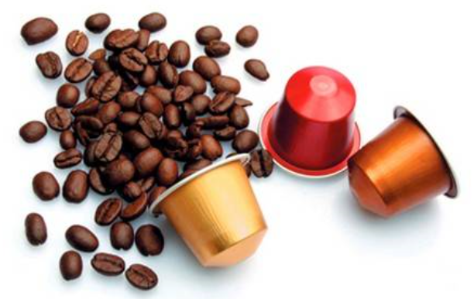
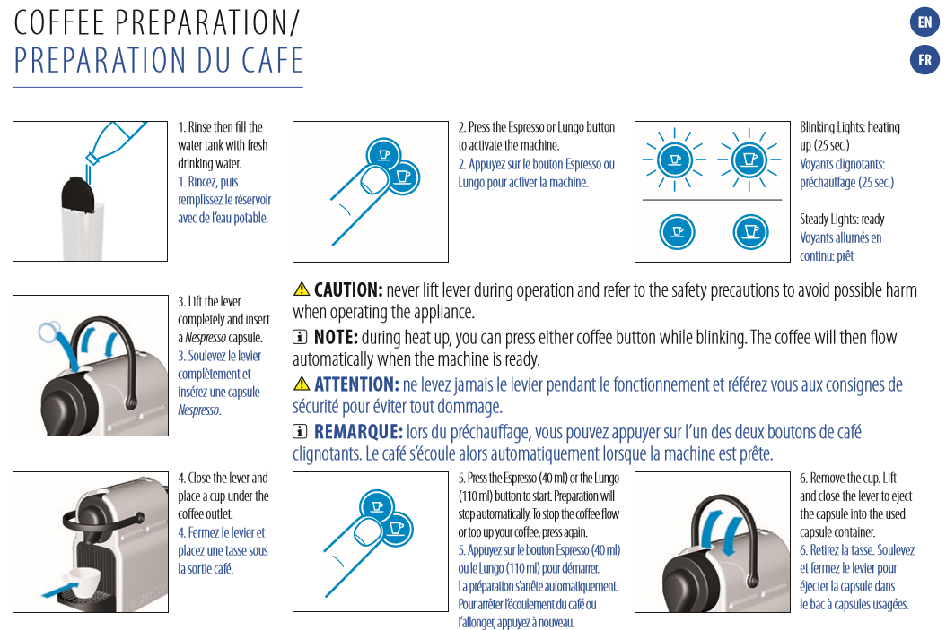

DISHWASHING MACHINE INSTRUCTIONS
Upload the crockery and put one tablet of detergent into the dispenser.
Starting a program:
1. Keep the appliance door ajar.
2. Press the on/off button to activate the appliance. Make sure that the appliance is in program selection mode.
3. Press the button related to the program you want to start. The related program indicator comes on.
4. Close the appliance door to start the program.
Cancelling the program:
Press and hold simultaneously 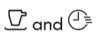 until the appliance is in program
selection mode. Make sure that there is detergent in the detergent dispenser before you start a new program.
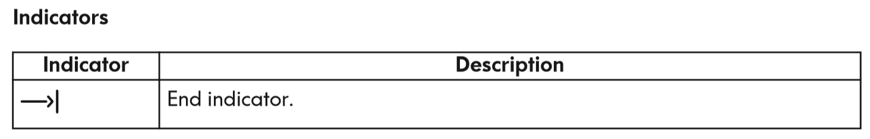
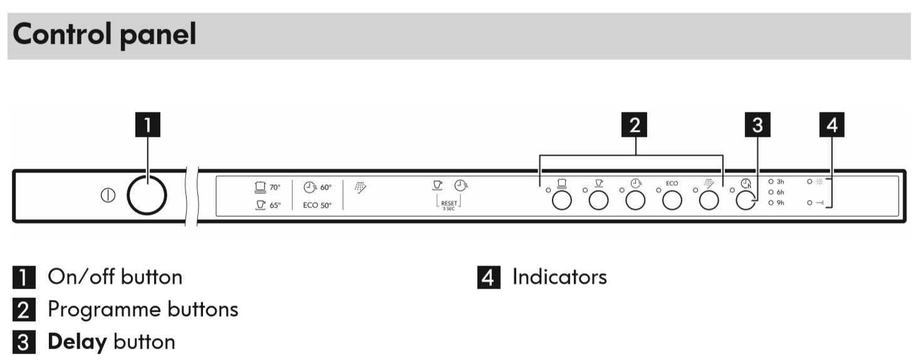
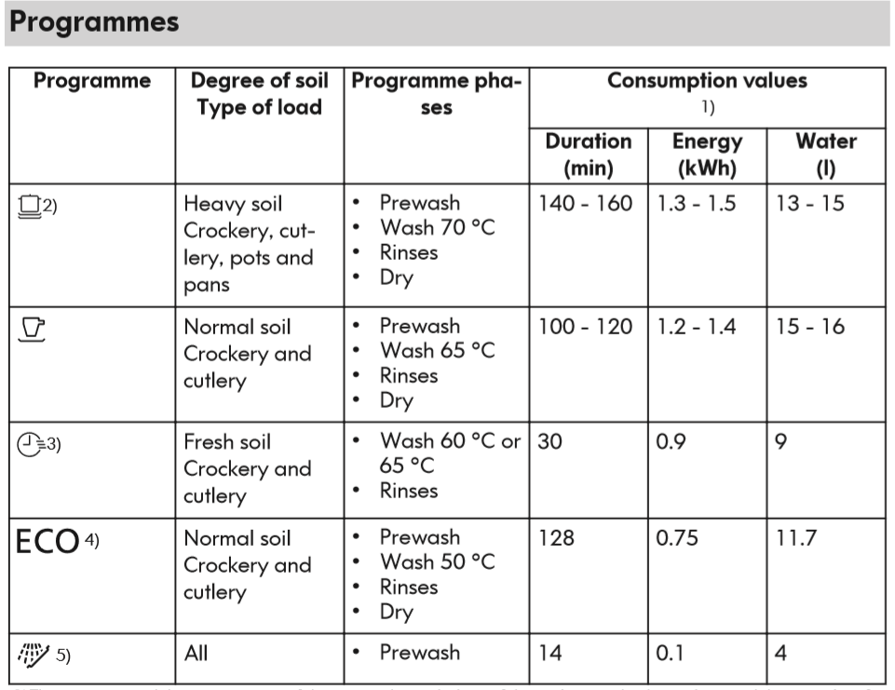
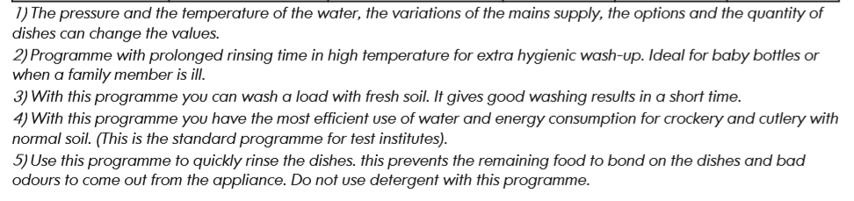

WASHING MACHINE INSTRUCTIONS - put 1 ball of soap inside the drum
Place the laundry in the drum and put one ball of detergent into the drum.
Close the drawer gently.
Select the required program by turning the program selector dial (1). The appliance now is switched on. The indicator light of button 4 starts to blink. At the end of the program, the selector dial must be turned on O, to switch the appliance off.
At the end of the program, the appliance stops automatically. After a few minutes the door can be opened.
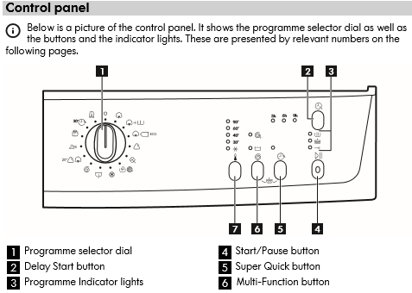
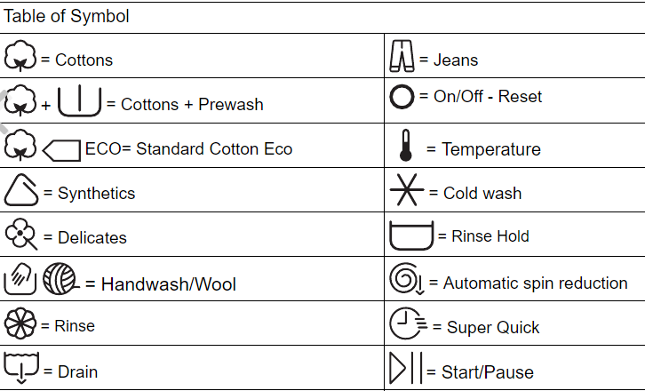

HOW TO COLLECT GARBAGE IN MILANO: you have to collect separatly:
- PAPER * CANS
- FOOD & ORGANIC WASTE (in the brown basket) * GLASS
AND BRING THEM INTO THE GARBAGE AREA IN THE COURT AT GROUND ZERO. THANK YOU!
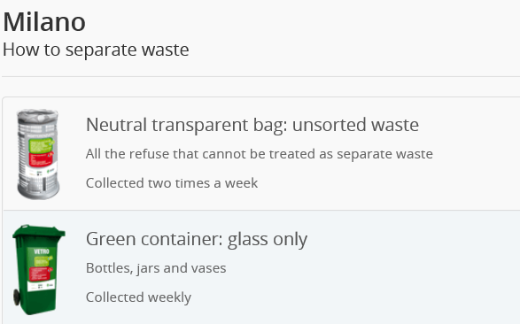
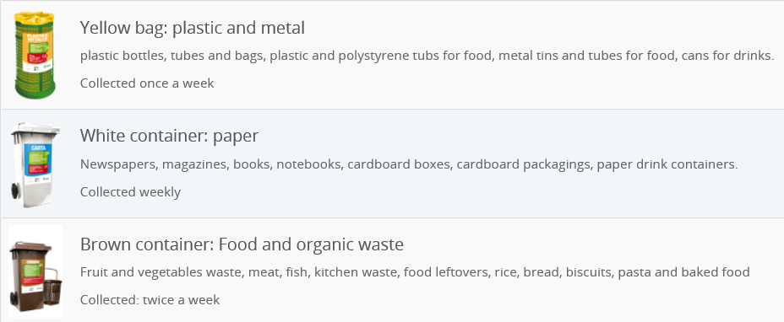

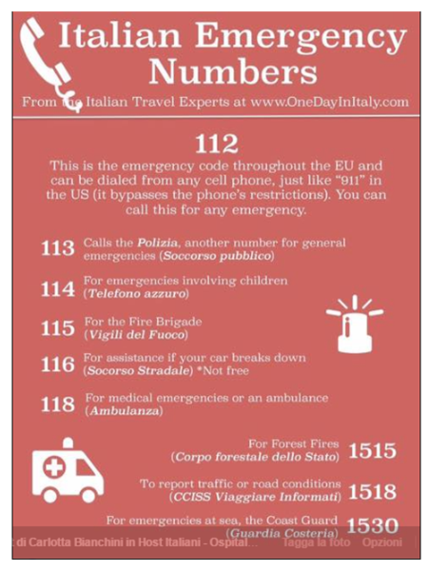

NICE TO KNOW IN THIS DISTRICT
Pharmacy
Via Garibaldi 32, Corso Francia 5, Via P. Montessori 14
Supermarket
Carrefour Vivi di Gusto, Piazza Tricolore 2
Carrefour Express, via Bertani 2
Punto, via Carlo Maria Maggi 10
Carrefour, via Garibaldi 54, via P. Montessori 41
Banks
Banca Popolare Commercio e Industria, via Garibaldi 54
Banca Nazionale del Lavoro, via Garibaldi 10
Intesa San Paolo, via P. Montessori 64
Bars
Piazza Sicilia, Il Colorificio: aperitives, snacks
Piazza Sicilia, Librosteria: bistrot with books, aperitives, snacks
Restaurants
Jubin, via P. Montessori 11 (one of the best in Milan for Chinese, Thai and Japanese food, fresh fish and sushi)
La Taverna dei Golosi, Corso Francia 12 (tipycal italian cuisine, meat Fiorentina, home made pasta, cakes)
Jazz Cafè, Corso Francia 8 (nightly bar, aperitives, american brunch during weekend, restaurant, jazz concerts)
Tara, Indian restaurant, via Cesena 16
Pizzeria
Pizza Ok, Piazza Francia 8 (a lot of various stuffs for this thin pizza, in summer outside Arco della Pace view)
Ciripizza, via Garibaldi 63 (classica napolitaner pizza)
Da Giuliano, via P. Montessori 60 (very soft slice of pizza, sweets, beer and wine, a tipycal italian trattoria)
Food Express and take away
Calù, Piazza Sicilia, a nice bistrot to eat outside or take away a good dinner
Eataly, Piazza XXV Aprile, is a high-end Italian food market/mall chain comprising a variety of restaurants, food and beverage stations, bakery, and retail items. Eataly was founded by Oscar Farinetti, an entrepreneur, formerly involved in the consumer electronics business, and is sponsored by Slow Food. On March 18, 2014 Eataly opened its big 5,000 sqm store in Piazza XXV Aprile in Milan.
Wine bar & happy hour
Cantine Isola, via P. Montessori 30 (ancient wine house, very good range of wines and tapas)
LiveCafè, Piazza Francia 2 (a smart place, with a good range of wines and champagne)
Bistrot Bar, Piazza Francia 1 (aperitives with a rich indian and Italian buffet, brunch)
Shops
Katay International Store (imported food from eastern countries), via Garibaldi 54
A lot of shops, bars, tobacconist are in Via P. Montessori and via Garibaldi, Corso Indipendenza and Corso Como (15 minutes walk)
Hair dresser
Basso, via Garibaldi 39, for ladies
Barber
Via P. Montessori 63, via Garibaldi 29
Laundry Simona, via Cavour 6
Place to be: don’t miss the colourful Isola, the chinese district between via Giusti, via P. Montessori and the narrow streets, full of computer & digital devices shops, barbers, restaurants, drugstores, department stores.
Parco del Castello, where you can run in the morning, or have a pleasant walk to the Castle and see museums. Nice kids playground with little train and carousels.
TOURISTIC INFORMATION ABOUT MILAN

http://www.turismo.milano.it

HOW TO COOK SPAGHETTI
From Barilla, the most famous Italian pasta company, some recipes to help you.
https://www.barilla.com/en-us

GO OUT FOR A RUN IN THE PARK
Let’s run a bit in the nearby, in Parco Francia. The house is under the arrow. The total distance is 3,6 km.
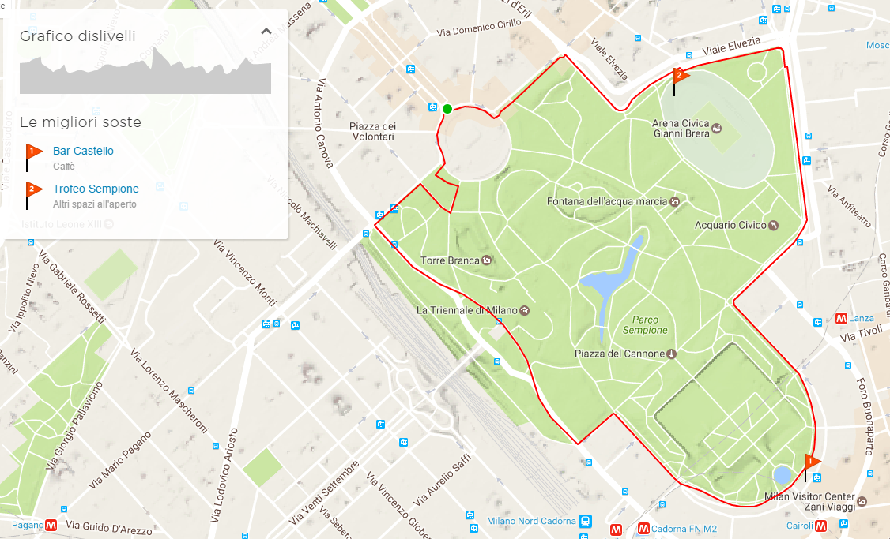

PUBLIC TRANSPORT IN MILAN - ATM
TICKETS
ATM meets all your mobility needs with a wide range of tickets:
- Urban tickets, for travels within Milan on the Milan city transport network
- Extra-urban tickets, for travels on intercity routes from the greater Milan area to the Milan terminals and vice versa, or for travels between towns in the greater Milan area
- Cumulative tickets, for travels on both the Milan city and intercity networks
- Fiera Milano tickets, to arrive to Rho exhibition center at Rho Fiera undergournd station
Urban tickets are priced at a flat rate. Extra-urban and cumulative tickets are priced progressively depending on the distance travelled between the departure point and the final destination.

Recommendations for Use
Tickets should be handled and stored with care.
Magnetic tickets have a magnetic strip: please do not fold, pierce or place tickets near sources of electromagnetic radiation. For the correct use of magnetic tickets on overground vehicles and in the underground please consult our FAQs on how to use the SBME (Magnetic and Electronic Ticketing System).
Stamped tickets are strictly personal and may not be used by third parties; they should be kept until you exit the station or descend from the vehicle and should be presented to ticket inspectors upon request. Passengers not in possession of a ticket, or with unstamped tickets, are liable to the fines specified in the regulations in force.

Stamping Tickets: all tickets should be stamped at the start of every journey.
Magnetic tickets should be stamped at the start of every journey and every time you change vehicles. To stamp your ticket insert it into the slot in the electronic ticket machine on board overground vehicles or at the ticket barriers in the underground.
Adjustment tickets when exiting from the Metro turnstiles

All tickets must be stamped even when leaving the metro stations. Passengers whose tickets have expired or which do not have the correct fare can purchase an adjustment ticket using the vending machines inside the turnstile line. Adjustment tickets are valid exclusively for stamping when you leave the metro. They cannot, for any reason, be used to continue your journey.
Passengers who have a ticket purchased using the ATM APP or with the SMS Ticketing service can stamp when they leave by moving their smartphone close to the turnstiles with QR Code reader, or print their ticket by entering PNR into the vending machines located inside the turnstile and stamp their printed ticket.

ATM for Families
Children travel free of charge on ATM vehicles when accompanied by an adult in possession of a valid ticket or travel card:
- Children aged 5 and under. Prams and pushchairs may be carried free of charge
- Children aged 6 to 10, up to two children.
We remind passengers that children must be in possession of ID as proof of age; children without ID must pay for their ticket.
These discounts are valid on the entire overground citywide network, including the Milan leg of intercity routes, and on the entire ATM underground network. There is no discount for school groups or organized tours.

Where To Buy Tickets

You can buy ATM tickets at any of the around 2.200 authorized outlets (bars, tobacconists, stationers, newspaper stands) found throughout the Milan area and on intercity routes.
The following tickets are available via the ATM MILANO APP: urban single ticket for 1.50€, urban day pass for 4,50€, Rho Fiera return ticket for 5€, single ticket to or from Rho Fiera for 2.50€ and day pass valid to and from Rho Fiera for 8€.
Sending an SMS with the message ATM to 48444 you can buy the urban ticket for 1.50€ and the Rho Fiera single ticket for 2.50 € (service available only for Tim, Wind, Vodafone, H3G customers).
You can also buy underground tickets at all underground stations from ticket machines selling various types of tickets; these machines accept both coins and bank notes, credits cards and bank cards.
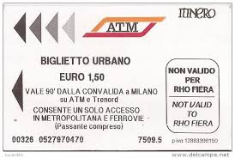
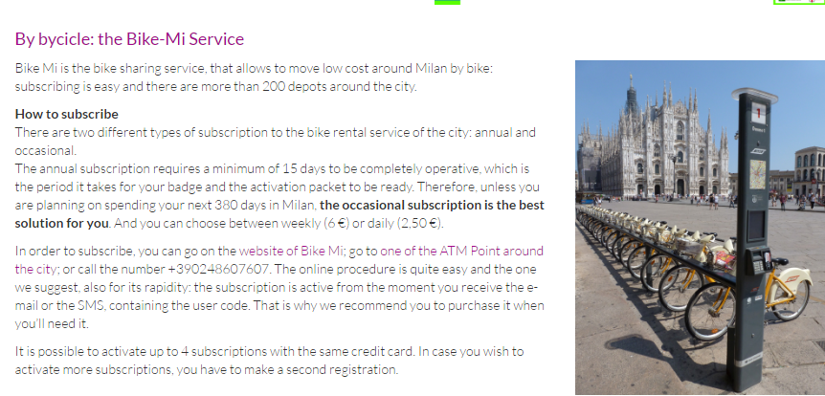
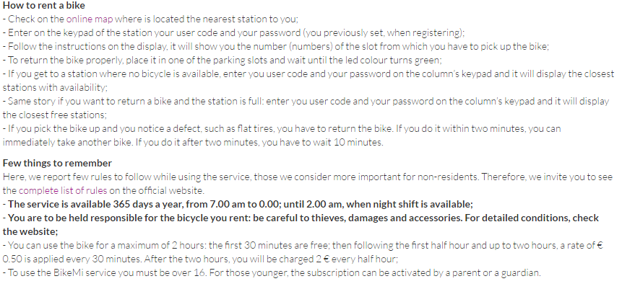

UNDERGROUND LINES
The nearest stop is PAGANO, 5 minutes walk, RED LINE
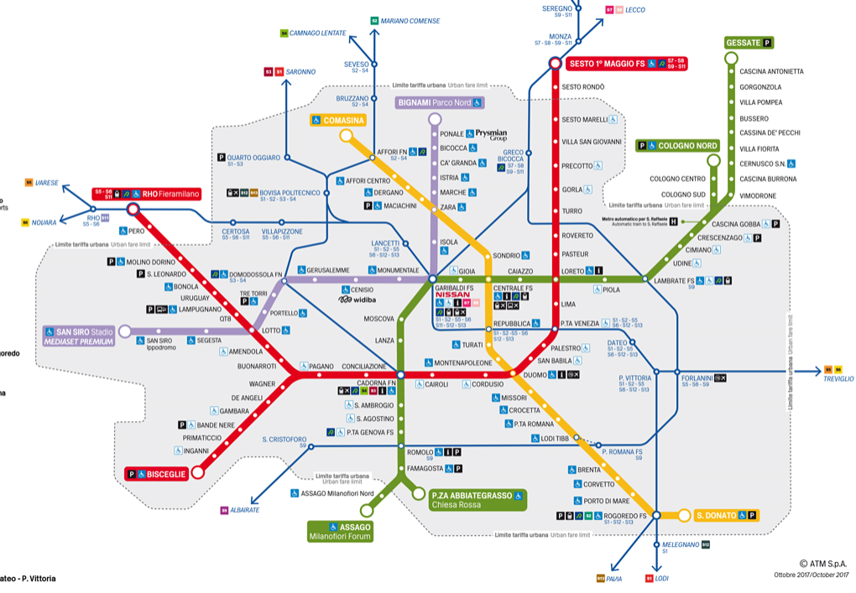
T A X I

TELEPHONE NUMBERS:
+39 02 4040
+39 02 6969
+39 02 8585

YOU CAN DOWNLOAD THIS APP, ALSO IN ENGLISH, YOU CAN CHOOSE THE PAYMENT (CASH,
CREDIT CARD) AND ASK FOR A 5-6 SEATS CAR.

